Coding Activity 8.1

Working With CSS And HTML Activity

#### **Learning Outcome Addressed**

 1. Apply styles to HTML code

Bottom of Form

### Adding Style To Web Pages

Now that you have some familiarity with CSS, you are going to get hands-on experience styling a web page.

Your task in this activity is to apply the following style requirements to the elements in the HTML page index.html:

* Change the text color for all h1 HTML tags to #0170FF
* Change the text color for all a HTML tags to #FF0101
* Implement the class content. This class should have the following style rules:
  + Padding should be 20px
  + Margin should be 10px
  + Text should be italic.
  + The background color should be #424EDC
  + The text color should be #ffffff
* Update the ul and li styles to match the following design:

[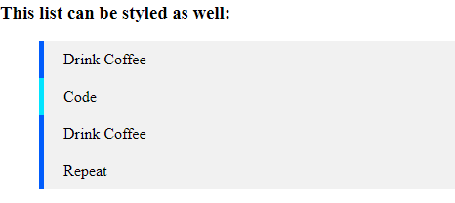](https://cdn.filestackcontent.com/5rBp11XTsaxiTGJCbx9I)

* Implement the footer CSS class. This class should have the following style rules:
  + The text should be centered
  + Padding should be 20px
  + Margin should be 10px
  + The background color should be #424EDC
  + The text color should be #ffffff

The style rules should be defined in the file styles.css and this file should be imported into the index.html file.

Hints:

* Use CSS classes to add style to specific HTML tags
* Make use of the class active to add styles the item list
* Make use of the style properties border-left and list-style-type to add styles to the item list

Task

* Follow instructions to add CSS styles to the index.html page.
* <!DOCTYPE html>
* <html>
* <head>
* <!-- TODO: import the CSS file styles.css -->
* </head>
* <body id="main">
* <h1>Introducing Styles to HTML</h1>
* <p>Learning how to make this page more stylish.</p>
* <div class="content">
* <p>CSS brings HTML to life. You can even style this <a href="#">link</a>! </p>
* </div>
* <h3>This list can be styled as well:</h3>
* <ul>
* <li>Drink Coffee</li>
* <li class="active">Code</li>
* <li>Drink Coffee</li>
* <li>Repeat</li>
* </ul>
* <div class="footer">2020 - MIT Course</div>
* </body>
* </html>

h1 {

}

a {

}

li {

}

.content {

}

.active {

}

.footer {

}